PRESSEMITTEILUNG

BUCHELE GMBH, Industriestraße 3, 73061 Ebersbach, www.buchele.de

The steel door manufacturer Buchele for the first time presents a multifunctional door made of thermoplastical material with a certified antiviral coating made of nano-silver particels.

Antiviral Doors by BUCHELE

Ebersbach, 11 June 2021 – Viruses and bacteria collect at doors and door handles – a challenge especially for medical, medical technology and other sensitive environments. The steel door manufacturer Buchele for the first time presents a multifunctional door made of thermoplastical material with a certified antiviral coating made of nano-silver particels with tested efficiency based on the RKI directive (1995) and according to ISO 21 702:2019 against bacteria and a bovine corona virus related tot he SARS-CoV-2.

The thermally separated profile construction with an integrated sealin system on three sides is made of light metal. It is 70 mm thick and available in the dimension range from 625 mm to 1500 mm width and 1750 mm to 3000 mm height. Optionally it may be equipped with tested additional functions such as sound insulation, burglary protection, bullet resistance or airtightness. Even shielding against X-rays is possible thanks to the special construction of the door. The design of door leaf surface can be manufactured according to customers wishes – depending on the scope of functions it can be transparent or individually designed. So the doors harmoniously match with the environment.

Improved hygiene due to barrier-free door opening
A barrier-free door opening and closing is provided by a compact designed swing door drive that stops immediately when the door is touched and reverses automatically. The installation of further safety components is ,therefore, not required. So the coated door construction withour door handle but with the rotary drive is the perfect solution for areas where sterility and fast and safe opening and closing is necessary. It is suitable for the use in clean rooms and laboratories, in companies working in sectors such as microelectronics, optics, genetics or food processing industries, as well as hospitals and nursing homes.

Simple exchange of existing doors
Most existing doors can be easlily replaced by the innovative door with antiviral coating made by Buchele. Antiviral coated door handles are included in the scope of delivery. –These door leaves too can be equipped with further functions such as sound insulation, burglary protection or bullet resistance. E. g. with an automatically retractable floor seal. For most frame types with suitable hinges the frame may remain in place. This guarantees a smooth and cost-effecive installation of the new door leaves.

Available photographic material
The following pictures are available in print quality:

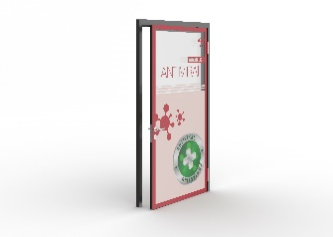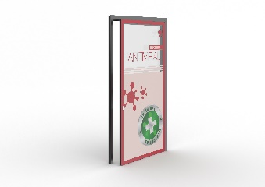
Source: Buchele GmbH
The steel door manufacturer Buchele for the first time presents a multifunctional door made of thermoplastical material with a certified antiviral coating made of nano-silver particels

About BUCHELE
BUCHELE GmbH located in the Swabian city of Ebersbach/Fils is known as one of the leading manufacturers of multi-functional steel doors and XXL-doors with various features. The company has about 100 employees and is known as an innovative manufacturer of doors and gates.
Online:
www.buchele.de

Press contact:

Tinoversum GmbH
Daniela Strohmaier
Büro Stauferpark
Manfred-Wörner-Straße 148
73037 Göppingen
Telefon: (07161) 15880-24
Telefax: (07161) 50478-58
daniela.strohmaier@tinoversum.de
www.tinoversum.de

