PRESSEMITTEILUNG

BUCHELE GMBH, Industriestraße 3, 73061 Ebersbach, www.buchele.de

High degree of customization and exceptional options to round off the sound insulation and safety topic
The new generation of multifunctional roller shutters

Ebersbach, 18 January 2022 – the steel door manufacturer Buchele Doors + Gates presents the latest generation of innovative roller shutters with a high degree of customization: The roller shutte from the series of „BUCHELE LM-Line“. It is an innovative construction made of patented single blades in sandwich construction and offers exceptional options around sound insulation and safety.

Innovative and patented blades in sandwich construction
„The roller shutter from our new LM-Line is one of our own developments for which we combined the know-how of our steel door production with the opportunities that light metal offers”, managing director Juergen Buchele reports. The key feature of the flush roller shutter is the particular construction of the door blade made of 60 mm thick extruded light metal profiles. The innovative, patented single blades are 160 mm high and put together in sandwich construction. „This way we remain flexible as far as requirements are concerned, plus we can respond to customer’s demands and set attractive accents and use only as much material as required for the respective purpose.“, Buchele explains the sustainable concept in production.

Tested and certified additional functions
If required the new roller shutter can be equipped with several additional functions. The certified values are convincing: Burglary protection up to RC4 according to DIN / TS 18194, Sound insulation up to 38 Db according to EN ISO 10140-2 or bullet resistance up to FB 4 according to EN 1522 as well as a combination of all of it. Buchele is convinced: „Our innovative construction combines the advantages of a roller shutter with sound insulation and bullet resistance. But in particular it can reliably protect you from burglary thanks to resistance class RC4 – which until now has often proven to be a weak point of roller shutter.“

Individual design with BUCHELE DELUXE
Protective, specially designed rubber lips allow that the roller shutter can be individually painted or imprinted. A belt system avoids mechanical traces on the surface and guarantees permanent protection of the blade surface. „The design of the door has been implemented so that there will be no abrasion on the surface of the blade so no ugly scratches will ruin the surface“, Juergen Buchele explains.
Next to the classic steel doors and gates the Deluxe-Design-Line by BUCHELE will, therefore, be continued in the roller shutter generation. This is especially useful for safety sensitive buildings, that have a high prestigiously character. Due to the individual design the doors can adapt the architecture and inconspicuously disappear, but still meet the practical requirements and protection.

Roller shutters with highest standards
Buchele standards are high: In the last view years the Swabian manufacturer of steel roller shutters already had high standard products with various functions in the range of supply. With the new generation the company has reached a new level in material characteristics, functional possibilities, construction and workmanship that underlines the high standards of quality of Buchele.

Various applications
The new roller shutters are currently available in dimensions of 5000 mm width and 5000 mm height. Larger dimensions can be implemented according to individual planning.
The new roller shutters by Buchele are suitable for the use everywhere were space-saving and flexible properties in combination with extraordinary safety and protectional functions are required. Therefore, it can be installed as invisible door behind an entrance door or side door of a public building. Production halls or powerplants where you have a high noise level can be attenuated and protected. Nevertheless, official requirements can practically be implemented.

Available photographic material:
You will find the following photographic material in print quality:

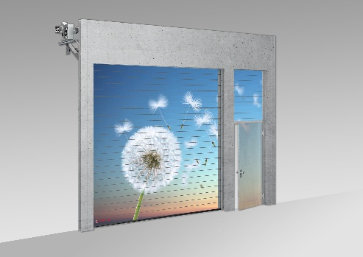  Bildquelle: Buchele GmbH  The innovative roller shutter by Buchele with its patented sandwich construction with single blades offers exceptional possibilities regarding sound insulation and safety. | 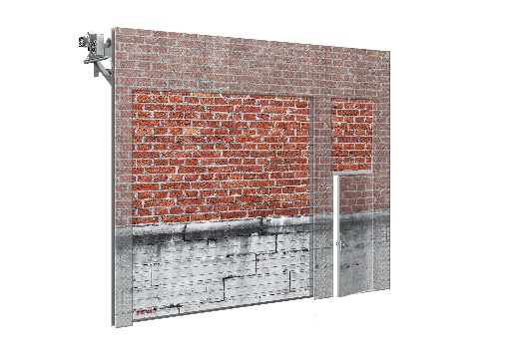  Bildquelle: Buchele GmbH  The innovative roller shutter by Buchele with its patented sandwich construction with single blades offers exceptional possibilities regarding sound insulation and safety.

About BUCHELE
BUCHELE GmbH located in the Swabian city of Ebersbach/Fils is known as one of the leading manufacturers of multi-functional steel doors and XXL-doors with various features. The company has about 100 employees and is known as an innovative manufacturer of doors and gates.
Online:
www.buchele.de

Pressekontakt:

Tinoversum GmbH
Daniela Strohmaier
Büro Stauferpark
Manfred-Wörner-Straße 148
73037 Göppingen
Telefon: (07161) 15880-24
Telefax: (07161) 50478-58
daniela.strohmaier@tinoversum.de
www.tinoversum.de

